**Modern Farmer: Android Mobile Application with IoT Integration for Modernizing Poultry Farming**

Luke Tembani Munyandu; Simbai Zindowe

*Department of Software Engineering, School of Information Sciences and Technology Harare Institute of Technology, Harare, Zimbabwe*

[lukemunyandu@gmail.com](mailto:lukemunyandu@gmail.com) ; [szindowe@hit.ac.zw](mailto:szindowe@hit.ac.zw)

**Abstract— Zimbabwe's poultry farming sector faces challenges due to limited information access, unreliable supply chains, disease management, and market opacity, hindering local farmers' growth. To combat these issues, we propose Modern Farmer, a mobile app leveraging technology to revolutionize poultry farming. It offers real-time environmental monitoring for chicken coops through IoT, automated air regulation, and infrared lighting. Interactive features predict feed quantity and weight per chick, alongside a poultry marketplace connecting farmers with customers. Modern Farmer prioritizes offline access and secure transactions, aiming to empower farmers, optimize operations, and boost economic outcomes in Zimbabwe's poultry industry.**

Keywords: poultry farming, mobile app, environmental control, IoT, automated systems, agricultural marketplace, rural development.

**INTRODUCTION**

Modern Farmer is a pioneering mobile application poised to transform poultry farming practices in Zimbabwe. By leveraging modern technology, it revolutionizes every aspect of the poultry farming journey, from chick procurement to sales. The app provides indispensable insights by offering real-time environmental data tailored to individual chicken coops. With this information, farmers can make informed decisions leading to operational optimization and enhanced productivity. Modern Farmer eradicates longstanding obstacles in the poultry industry, including disease management, inventory issues, and market hurdles, by seamlessly connecting users with suppliers and resources, even in remote areas.

Poultry farming in Zimbabwe faces significant challenges including limited access to critical information, unreliable supply chains for chicks, disease management issues, and opaque market dynamics. These obstacles hinder the growth and economic prosperity of local farmers. Modern Farmer addresses these challenges by developing and implementing innovative solutions through its mobile technology platform. The app provides real-time environmental data monitoring and facilitates improved access to resources and markets, aiming to overcome the barriers hindering the poultry industry's development and enhance economic outcomes for farmers.

To ensure the well-being of the poultry and promote healthy living conditions, the app incorporates various tools and technologies. One essential component is the use of IoT devices such as Raspberry Pi, MQ135 sensors, and DTH11 & DTH22 temperature and humidity sensors. These devices work in tandem to monitor and regulate the coop environment, ensuring optimal conditions for the chickens. For instance, maintaining an appropriate temperature range between 21°C to 29°C, as recommended by experts, is crucial for the chickens' health and productivity. Modern Farmer utilizes this data to automate tasks such as adjusting air regulation and controlling infrared lighting systems, thus mitigating risks of heat and cold stress.

Existing research emphasizes the significance of providing chickens with a controlled environment to meet their thermal requirements. Various studies have explored techniques such as evaporative cooling systems and insulated roofs to regulate coop temperature effectively. However, manual intervention and reliance on electrical energy remain prevalent in many existing systems. Modern Farmer addresses these limitations by offering an automated solution that optimizes temperature control while minimizing energy consumption and maintenance costs.

In summary, Modern Farmer represents a paradigm shift in poultry farming, offering a comprehensive solution to address longstanding challenges in the industry. By integrating cutting-edge technology and innovative strategies, it empowers farmers to optimize operations, improve productivity, and navigate the complexities of poultry farming with ease.

**METHODOLOGY**

The Modern Farmer project utilizes an agile methodology to provide a flexible, iterative, and collaborative approach to addressing the challenges faced by poultry farmers in Zimbabwe. The methodology consists of several key phases structured into iterative sprints:

Sprint Planning and Requirements Gathering:

User Stories and Backlog Creation: Conduct workshops and interviews with poultry farmers to gather requirements, create user stories, and prioritize them into a product backlog.

Automated Environmental Control System: Design and Development: Develop an air regulation system using IoT devices (Raspberry Pi, MQ135, DTH11 & DTH22 sensors) for monitoring and adjusting ventilation and airflow.

Implementation and Testing: Integrate the system with the app and conduct unit and integration testing.

Deployment and Feedback: Deploy to pilot farms, collect feedback, and refine in the next sprint.

Infrared Lighting System: Design and Development: Develop an infrared lighting system that adjusts based on temperature readings.

Implementation and Testing: Integrate with the app and validate through testing.

Deployment and Feedback: Roll out to pilot farms, gather feedback, and iterate.

Interactive Feed Management System: Design and Development: Create a feed management system using data analytics for real-time feed quantity and weight gain predictions.

Implementation and Testing: Integrate with the app, perform testing, and pilot with a sample group.

Deployment and Feedback: Deploy more broadly and refine based on feedback.

Poultry Marketplace Integration: Design and Development: Build a digital marketplace within the app for product showcasing and buyer engagement.

Implementation and Testing: Integrate the marketplace, conduct beta testing, and refine functionalities.

Deployment and Feedback: Launch to all users, gather feedback, and iterate.

Sprint Review and Retrospective: Conduct sprint reviews to demonstrate features and collect stakeholder feedback.

Hold retrospectives to discuss improvements and plan subsequent sprints.

Continuous Monitoring and Improvement: Data Collection and Analysis: Monitor performance, collect data, and analyze results.

Feedback Loop and Iteration: Update and refine the app and systems based on feedback and data analysis, iterating through additional sprints as needed.

This Agile methodology ensures the Modern Farmer project remains responsive to farmers' needs, continuously improving and delivering effective solutions for enhancing productivity and economic outcomes.

**RELATED WORK**

Chicken Coop Automatic Remote Visual Monitoring System

In a study conducted by S. Wahjuni et al. (2022), a visual monitoring system was proposed and developed to assist farmers in monitoring their chicken coop, typically situated at a distance from their residences. The system relies on sufficient bandwidth for video transmission over the internet, a resource often limited in urban areas. The research aimed to create an automatic chicken coop remote monitoring system and determine the optimal video resolution for transmission. An 8 MP Raspberry Pi V2 records the video, transmitting results to Google Drive via the Google Drive API. Additionally, a live-streaming video from the chicken coop is accessible through a basic HTTP web page using ngrok as tunneling software, enabling public access via any web browser. Experiments involved three video resolutions (640x480, 800x600, and 1024x768) with frame rates of 15 and 30. Each scenario had five-minute duration, repeated 12 times. While beneficial to farmers, the system has limitations, notably the inability to remotely control situations without manual intervention. Another limitation is the requirement for the responsible person to closely monitor the streamed video to promptly address any anomalies, resembling the effort of being physically present in the chicken coop.

Internet Based Smart Poultry Farm Mobile System

Goud and Sudharson (2015) devised an internet-based smart poultry farm mobile system that incorporated wireless sensors to notify registered individuals in charge of farms about various environmental parameters, including temperature, humidity, and water levels. A notable drawback of their system was its reliance on GSM to dispatch alerts to farm managers. This approach, dependent on GSM for information transfer, proves ineffective in areas with no cellular service. The system operates by sending a code word SMS to GSM modules, retrieving current parameter values, allowing users to take necessary actions. However, this method is susceptible to issues like network errors or failure to operate when the SIM card is not recharged.

**SOLUTION**

Modern Farmer project presents a comprehensive solution to the challenges faced by poultry farmers in Zimbabwe through the integration of cutting-edge technology and innovative agricultural practices. By leveraging mobile applications and sophisticated monitoring systems, the project aims to revolutionize poultry farming, enhance productivity, and improve the livelihoods of farmers.

Automated Environmental Control System: To address the issue of maintaining optimal environmental conditions within chicken coops, an automated air regulation system will be implemented. This system will continuously monitor humidity levels and air quality parameters, adjusting ventilation and airflow as necessary to ensure the well-being of the poultry flock. By providing real-time environmental data and automating control processes, the system minimizes the risk of disease outbreaks and improves overall poultry health.

Infrared Lighting System: Temperature fluctuations can adversely affect poultry health and productivity. To mitigate this risk, an automated infrared lighting system will be developed. This system will adjust lighting levels based on temperature readings within the chicken coop, ensuring a comfortable and conducive environment for the poultry. By optimizing lighting conditions, the system promotes better growth rates and reduces stress among the flock.

Interactive Feed Management System- Accurate feed management is essential for optimizing poultry growth and minimizing feed wastage. Modern Farmer will develop an interactive system that provides real-time information on the required feed quantity for each batch of poultry and estimates the expected weight gain per chick. By utilizing data analytics and predictive modeling, the system enables farmers to make informed decisions regarding feed allocation, leading to improved efficiency and cost savings.

Poultry Marketplace Integration - Access to markets is critical for the success of poultry farmers. The project will create a digital marketplace that connects farmers with a broad customer base, facilitating efficient and diverse product sales. Through the mobile app, farmers can showcase their products, manage inventory, and engage with buyers, thereby expanding market reach and increasing revenue opportunities.

Key Features and Benefits:

Enhanced Productivity: By automating critical aspects of poultry farming, such as environmental control and feed management, the "Modern Farmer" project enhances productivity and maximizes yield potential.

Improved Health and Welfare: Real-time monitoring of environmental conditions and proactive management of lighting and ventilation contribute to improved poultry health and welfare, reducing the incidence of diseases and mortality rates.

Market Access and Economic Growth: The integration of a digital marketplace enables farmers to access a wider customer base, increasing sales opportunities and driving economic growth within the poultry industry.

Sustainable Agriculture: Through the use of advanced technology and data-driven solutions, the project promotes sustainable agricultural practices, minimizing resource wastage and environmental impact.

Architecture

Modern Farmer utilizes client-server architecture to streamline communication and data exchange between key components:

Server: Central hub for data storage and processing, managing information related to poultry farming activities, such as chick inventory, feed prices, and supplier details. Processes data from IoT devices and handles requests from client applications.

Client Applications (Mobile and Web): Interfaces for farmers and suppliers to interact with the system. Mobile app provides on-the-go access to farm monitoring and purchasing, while web app offers comprehensive features for analytics and inventory management.

IoT Component: Collects environmental sensor data from chicken coops and transmits it to the server for analysis. Enables real-time alerts and notifications to mobile app users.

Data Flow:

IoT to Server: Sensor data transmitted to server for storage and analysis.

Server to Mobile App: Real-time alerts and farm data sent to mobile app for farmers' access.

Server to Web App: Comprehensive data accessible through web app for inventory management and supplier interactions.

Sync Mechanism:

Ensures data consistency across all platforms, with updates from web app and IoT devices reflected in real-time on mobile app, empowering farmers with up-to-date information for informed decision-making.

This architecture optimizes poultry farming operations, enhances farm management, and facilitates seamless interactions between farmers and suppliers.

**RESULTS AND FUTURE WORKS**

Suppliers Portal

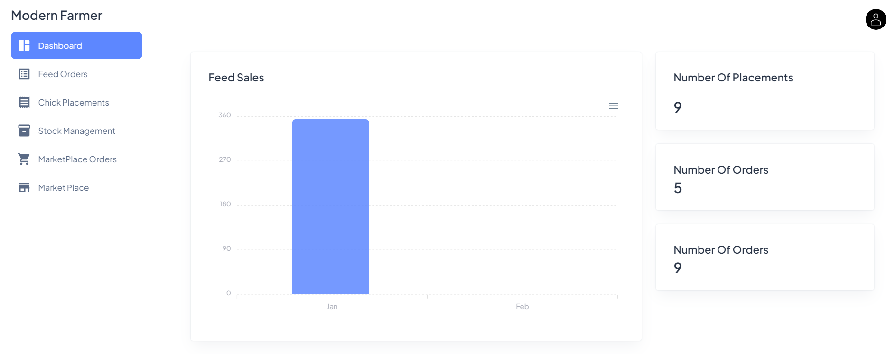

Farmer’s View

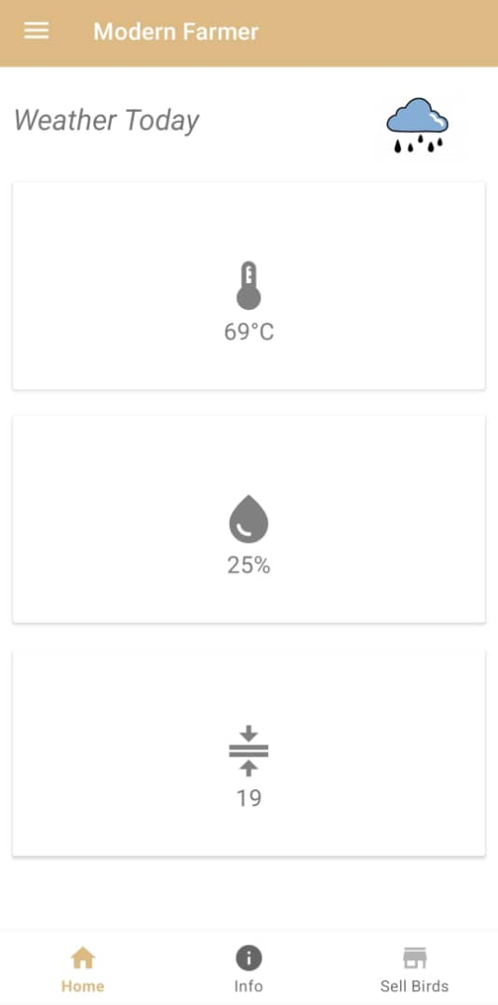

|  |  |  |
| --- | --- | --- |
| Objective | Fully Achieved | Partially Achieved |
| To implement automated air regulation, adjusting based on humidity levels and air quality parameters for optimal environmental control | ✔ |  |
| To develop an automated infrared lighting system that adjusts based on temperature level. | ✔ |  |
| To develop an interactive system to provide real-time information on both the required feed quantity for each input batch and the expected weight per chick. | ✔ |  |
| To create a poultry marketplace, connecting farmers with a broad customer base for efficient and diverse product sales. | ✔ |  |

IoT Components

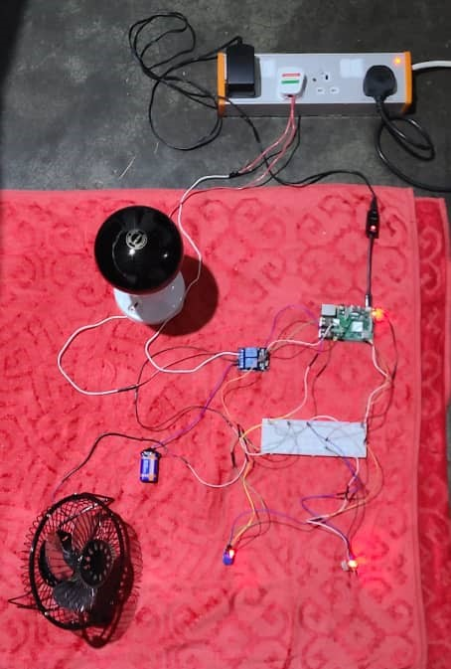

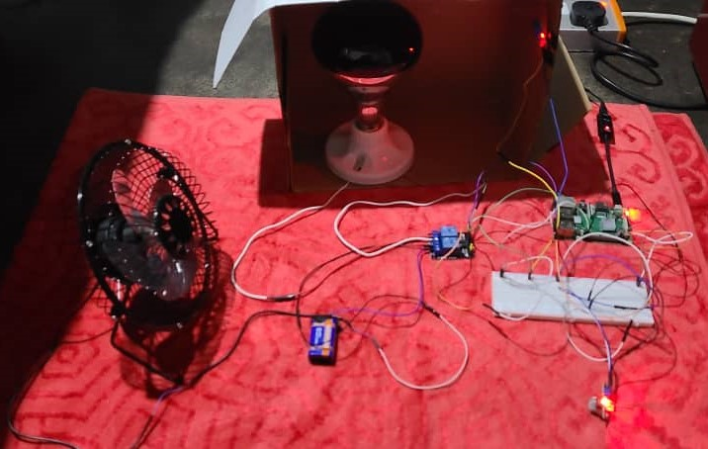

**FUTURE WORKS**

Some potential areas of future work for the system could include:

1. **Automated Feeding Integration:** Integrate automated feeding systems with real-time data control to optimize feed utilization and minimize wastage.
2. **Decision Support Tools:** Develop machine learning-based decision support tools for optimizing feed formulation, disease management, and breeding programs.
3. **Livestock Management Expansion:** Expand the poultry management system to include tailored features for managing pigs, cattle, and other livestock species.
4. **Predictive Maintenance:** Implement predictive maintenance algorithms to anticipate and prevent IoT device failures, ensuring continuous operation.
5. **Mobile Diagnostic Tools:** Create mobile diagnostic tools for farmers to perform basic health assessments and early disease detection in poultry flocks.
6. **Continuous Feedback and Iteration:** Establish mechanisms for continuous user feedback to guide iterative improvements and updates to the poultry management system.

**CONCLUSION**

Modern Farmer introduces a transformative approach to poultry farming in Zimbabwe by leveraging advanced technology and mobile applications. Through comprehensive client-server architecture, the system ensures efficient data management and real-time communication between IoT devices, mobile, and web applications. Key features such asautomatedenvironmental control, infrared lighting, and an interactive marketplace empower farmers with essential tools to enhance productivity, manage resources efficiently, and expand market access. By addressing critical challenges and promoting sustainable agricultural practices, "Modern Farmer" significantly improves poultry farming operations, contributing to economic growth and food security in rural communities.

**ACKNOLEDGEMENTS**

I would like to take this opportunity to express my sincere gratitude to all those who have contributed to the successful completion of this project.

First and foremost, I wish to thank God for His grace, which has supported me from my first day of pre-school to reaching this significant milestone.

I am deeply grateful to my supervisor, Ms. Simbai Zindowe, for her invaluable guidance, expert advice, and unwavering support throughout the project. Her mentorship has been crucial in shaping the direction of this work and helping me develop essential skills and knowledge in this field.

I also wish to extend my thanks to the staff of the Software Engineering Department for their assistance and support, particularly during the challenging phases of this project. The department's resources and facilities have been instrumental in conducting the research and development activities.

My sincere appreciation goes to the Development Team at FIGJAM for their exceptional collaboration and technical expertise. Their dedication and hard work have been pivotal in overcoming obstacles and ensuring the project's success.

Lastly, I would like to thank all the participants who volunteered their time and efforts to provide valuable data for this project. Their cooperation and contributions have been essential to the successful completion of this work.

Once again, I extend my heartfelt thanks to everyone who has played a role in this project. Your support and contributions have been invaluable, and I am profoundly grateful for your presence in my life.

**REFERENCES**

[1] Archana M P1, Uma S K2, “Monitoring and controlling of poultry farm using IOT”, International Journal of Innovative Research in Computer and Communication Engineering, Vol. 6, Issue 4, April 2018.

[2] Zainal H. C. Soh1, Mohd H. Ismail1, “Developement of automatic chicken feeder using Arduino Uno”,IEEE, Dec 2017.

[3] Danar Wicaksono, Ratna Mayasari, “Design and Analysis Automatic Temperature control in the Broiler poultry farm based on wireless sensor network”, 2nd International Conferences on Information Technology, Information Systems and Electrical Engineering (ICITISEE), Nov 2017.

[4] Raghudathesh G P1, Deepak D J2“IOT based intelligent poultry management system using Linux embedded system”, IEEE, Aug 2017.

[5]. Geetanjali A. Choukidar, Prof. N.A. Dawande, “Smart poultry farm automation and monitoring system”, IEEE, June 2017.

[6]. Ayyappan.V, Deepika.T, “Smart poultry farm automation and monitoring system”, IOT Based Smart Poultry Farm, South Asian Journal of Engineering and Technology Vol.3, No.2 (2017) 77– 84,07/03/2017

[7] Zhang H, Li J, Wen B, Xun Y, Liu J. Connecting Intelligent Things in Smart Hospitals Using NB-IoT. IEEE Internet of Things Journal. 2018; 5(3): 1550-1560.

[8] Shyam GK, Manvi SS, Bharti P. Smart waste management using Internet-of-Things (IoT). In the Proceedings of the 2nd International Conference on Computing and Communications Technologies (ICCCT). Chennai. 2017: 199-203.

[9] UpSkill Learning. ESP8266: Get Started with ESP8266 Programming NodeMCU Using Arduino IDE. First Edition. CreateSpace Independent Publishing Platform. 2016.

[10] Sipani JP, Patel RH, Upadhyaya T. Temperature and Humidity Monitoring & Control System Based on Arduino and SIM900A GSM Shield. International Journal of Electrical, Electronics and Data Communication. 2017; 5(11): 62-68.

[11] Osaretin CA, Edeko FO. Design and Implementation of Solar Charge Controller with Variable Output. Journal of Electrical and Electronics Engineering. 2016; 12(2): 40-52.

[12] Kamar I, Hamie A, Parag C. Internet of Things in Learning Systems - A Perspective of Platforms. International Journal of Advanced Research in Computer Science. 2016; 7(2): 52-56.